

19P0012 AITZAZ TAHIR CH

DATA BASE LAB ASSIGNMENT 2 SIR MUHAMMAD USMAN



**Question # 01**

source C:\Users\HP\Desktop\university.sql

use university;

**Creating Table courses:**

create table courses(

course_code varchar(10) primary key,

course_name varchar(20) not null,

credit_hours numeric(1) not null);

**Creating Table enrolled:**

create table enrolled(

course_code varchar(10) not null,

roll_no varchar(10) not null,

constraint pk_enroll primary key(course_code, roll_no),

constraint fk_cou foreign key (course_code) references courses(course_code),

constraint fk_roll foreign key (roll_no) references student(roll_no));

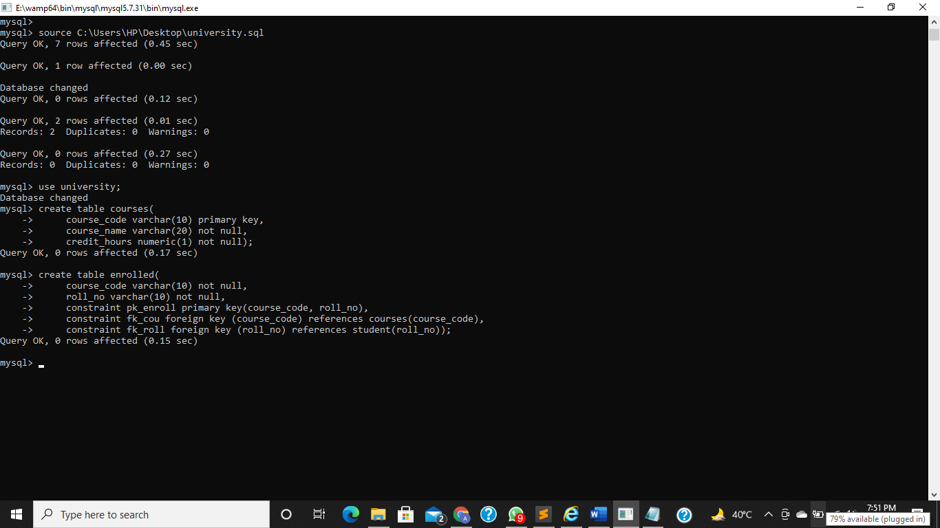

**Php code in attached Php files.**

**Values inserted in tables through Php MyAdmin.**

**Web pages:**

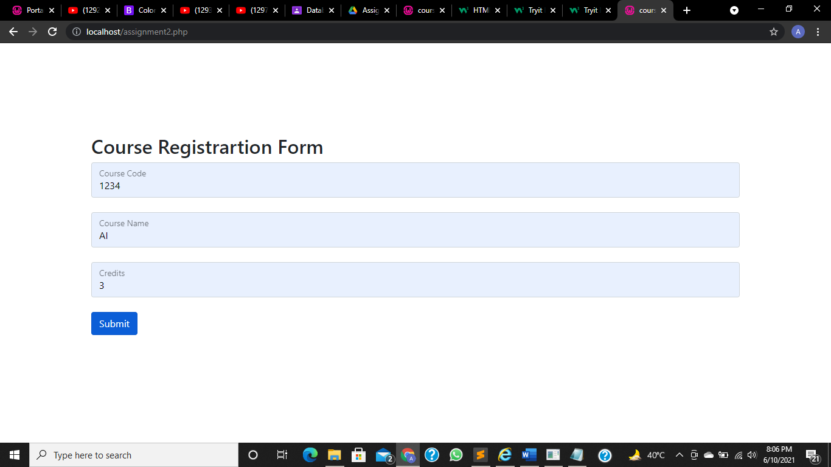

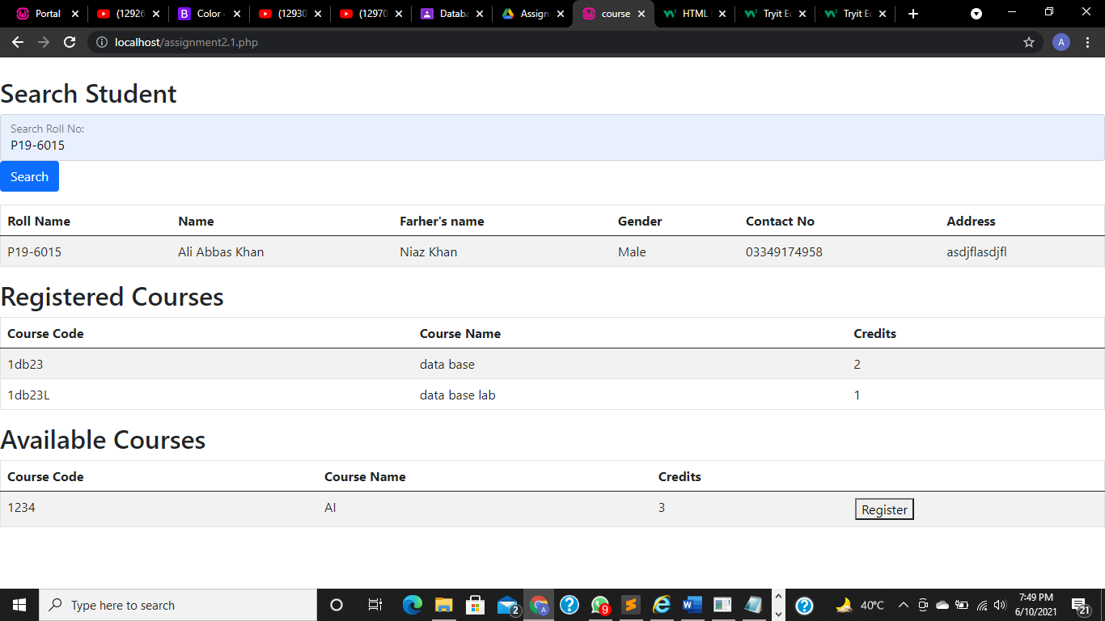

**Question # 02**

CREATE DATABASE person;

use person;

**Creating Table Users:**

CREATE TABLE Users(

user_id INT PRIMARY KEY,

username VARCHAR(15),

password VARCHAR(15),

email VARCHAR(20)

);

**Creating Table Summary:**

CREATE TABLE Summary(

id INT PRIMARY KEY,

total_users INT,

Yahoo INT,

Outlook INT,

Gmail INT

);**Inserting data:**

insert into users values (1,"Salman","1234","salman@gmail.com");

insert into users values (2,"Harry","9090","harry@outlook.com");

insert into users values (3,"Atif","Pak123","atif@yahoo.com");

insert into users values (4,"Fawad","Pesh098","fawad@gmail.com");

insert into users values (5,"Mehwish","asd","mehwish@yahoo.com");

insert into users values (6,"Babar","Qwe876","babar@yahoo.com");

insert into summary values (1,6,3,1,2);

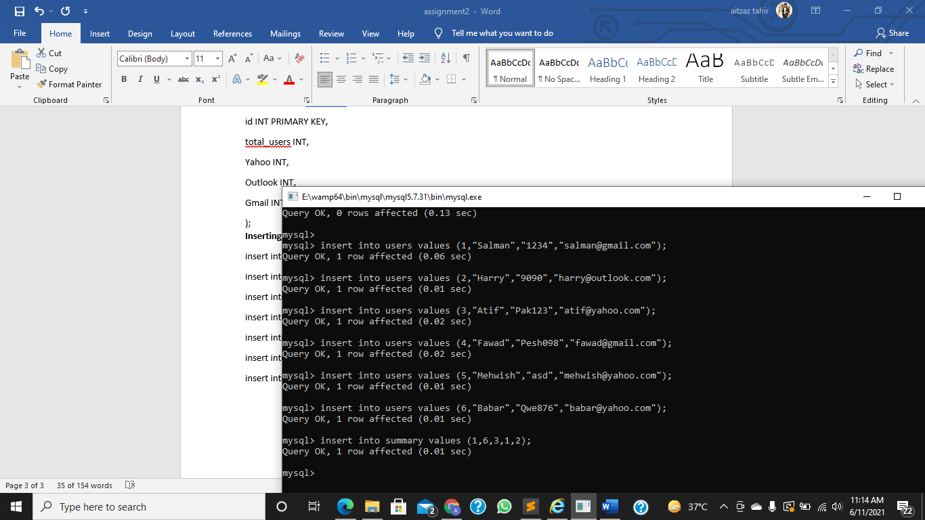

**Creating Trigger:**

Delimiter $$

create trigger update_tr

after update on users

for each row begin

if(old.email like "%yahoo%") then

update summary set yahoo=yahoo-1;

elseif(old.email like "%outlook%") then

update summary set outlook=outlook-1;

elseif(old.email like "%gmail%") then

update summary set gmail=gmail-1;

end if;

if(new.email like "%yahoo%") then

update summary set yahoo=yahoo+1;

elseif(new.email like"%outlook%") then

update summary set outlook=outlook+1;

elseif(new.email like "%gmail%") then

update summary set gmail=gmail+1;

end if;

end$$

delimiter ;

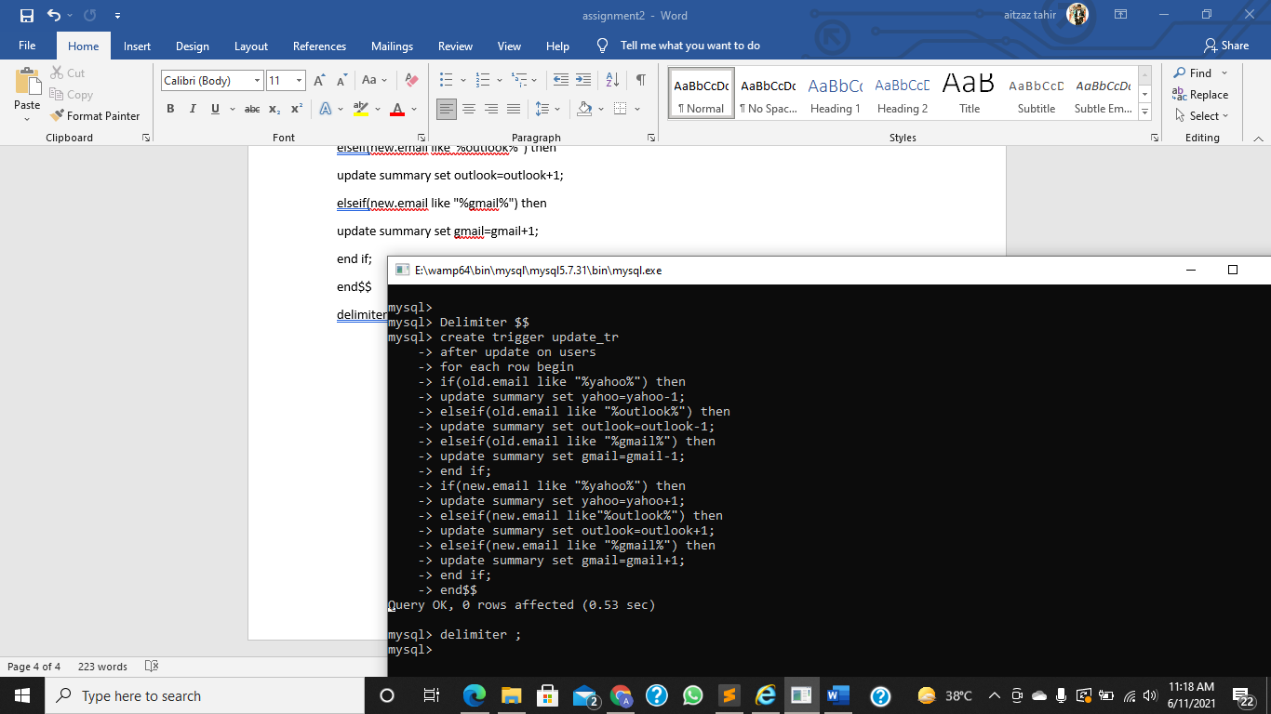

**Before Updation:**

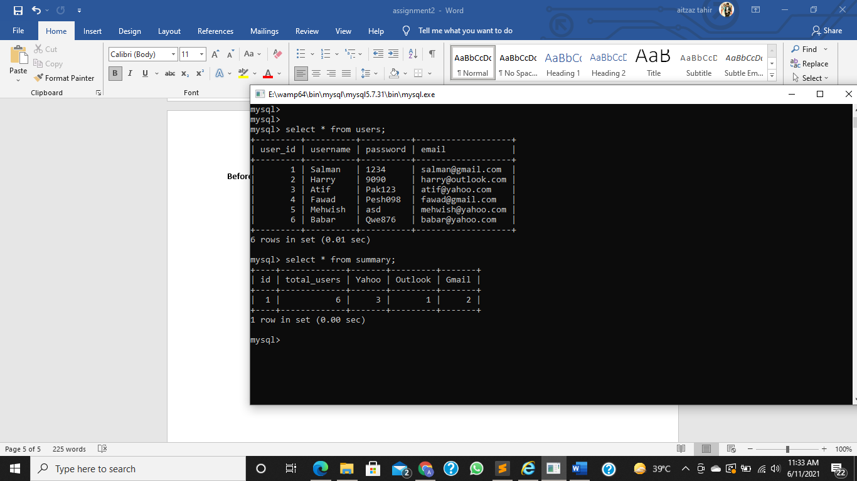

**After Updation:**

